Project Design Phase - II Technology Stack (Architecture & Stack)
Date | 4/11/25
Team ID | NM2025TMID06168
Project Name | Medical Inventory Management System
Maximum Marks | 4 Marks

Technical Architecture Overview
The Medical Inventory Management System is built as a cloud-based Salesforce application designed to automate and streamline inventory operations within healthcare organizations. The architecture ensures seamless interaction between users, system modules, databases, and external services — providing secure, scalable, and intelligent inventory management.

Key Components
1. User Interface (UI)
- Accessible through web browsers and mobile devices using Salesforce’s responsive design.
- Provides interactive dashboards for real-time visibility of inventory, supplier performance, and purchase order status.
- Supports role-based interfaces for administrators, pharmacists, and suppliers.

2. Application Logic / Technology Modules
- Inventory Management Module:
Manages the complete lifecycle of medical products, including cataloging, stock updates, expiry tracking, and reorder management.
- Supplier Management Module:
Maintains supplier details, contact information, delivery performance, and order history to ensure reliable partnerships.
- Purchase Order Module:
Facilitates purchase order creation, approval, tracking, and fulfillment. Automatically adjusts stock levels upon order completion.
- Reporting and Analytics Module:
Generates real-time reports and dashboards for stock levels, supplier performance, purchase trends, and expiry alerts.
- Authentication and Security Module:
Implements Salesforce role-based access control (RBAC), ensuring only authorized users can view or modify sensitive data.
Includes audit trails for tracking all inventory transactions and system activities.

3. Data Storage and Services
- Salesforce Databases:
Store structured data such as product details, supplier records, purchase orders, and inventory logs.
Utilizes custom objects like Medicine__c, Supplier__c, Purchase_Order__c, and Inventory_Transaction__c.
- Cloud Storage (Optional):
Used for secure backups of reports, logs, and historical transaction data to ensure data continuity and compliance.

4. External Interfaces / APIs
- Supplier APIs Integration:
Enables automatic synchronization with supplier systems for product availability, price updates, and order confirmations.
- Email / SMS Notification APIs:
Sends automated alerts to administrators regarding low stock, near-expiry products, and pending purchase approvals.

5. Machine Learning / AI Components (Optional)
- Predictive Analytics:
Uses historical sales and usage data to forecast future demand, helping to prevent both overstocking and shortages.
- Intelligent Alerts:
Provides automated expiry alerts and AI-driven suggestions for optimal reorder timing and quantity.

6. Infrastructure Demarcation
- Cloud Components:
  - Salesforce platform (core application)
  - Salesforce databases (custom objects and records)
  - Optional AI and predictive analytics services
- Local Components:
  - Admin/staff access via web or mobile interface
  - Optional barcode scanners for product entry and verification

Summary

This Technical Architecture ensures a highly integrated and secure environment for managing medical inventories.
By leveraging Salesforce’s cloud infrastructure, automation tools, and optional AI capabilities, the system delivers:
- Real-time tracking,
- Accurate reporting,
- Predictive insights, and
- Operational efficiency
for hospitals, clinics, and pharmaceutical organizations.
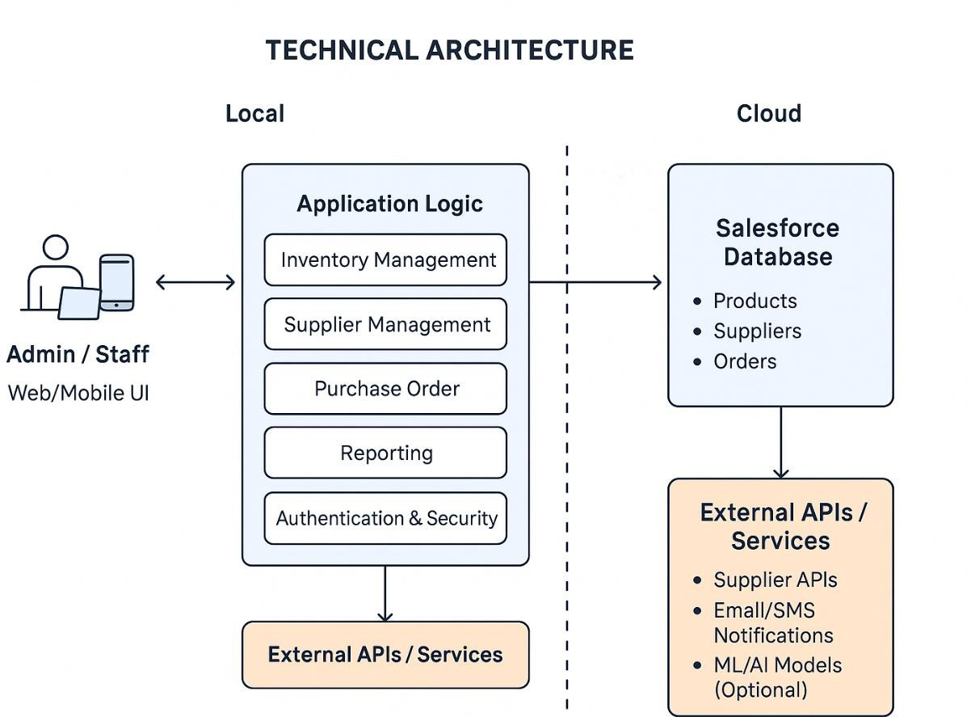

Table-1: Components & Technologies:

S.No | Component | Description | Technology
1 | User Interface | Inventory staff and admin interact via web and mobile dashboards | Salesforce Lightning Web UI / Mobile UI
2 | Application Logic-1 | Manages supplier information and performance tracking | Salesforce Apex, Flow, and Triggers
3 | Application Logic-2 | Handles product cataloging, stock updates, and expiry date monitoring | Apex Classes, Flow, Process Builder

S.No | Component | Description | Technology
4 | Application Logic-3 | Manages purchase orders from creation to completion | Salesforce Apex, Flow, Process Builder
5 | Database | Stores product, supplier, purchase order, and inventory records | Salesforce Custom Objects & Tables
6 | Cloud Database | Managed by Salesforce cloud backend | Salesforce Cloud Database
7 | File Storage | Stores reports, logs, and documents | Salesforce Files / Attachments
8 | External API-1 | Integrates with supplier APIs for stock updates | REST / SOAP APIs
9 | External API-2 | Sends notifications to staff about low stock or near-expiry products | Email / SMS APIs (Twilio, SendGrid)
10 | Machine Learning Model | Optional predictive analytics for demand forecasting and expiry prediction | Salesforce Einstein / ML Models
11 | Infrastructure (Server / Cloud) | Hosted on Salesforce SaaS cloud platform with secure access | Salesforce Cloud (SaaS)

Table-2: Application Characteristics:

S.No | Characteristics | Description | Technology
1 | Open-Source Frameworks | Not required; built on proprietary Salesforce platform | N/A
2 | Security Implementations | Role-based access control, field-level security, and profile- based permissions | Salesforce Profiles, Permission Sets, Field- Level Security
3 | Scalable Architecture | SaaS-based, horizontally and vertically scalable via Salesforce cloud | Salesforce Cloud Architecture

S.No | Characteristics | Description | Technology
4 | Availability | Highly available with Salesforce cloud hosting | Multi-instance Load- Balanced Salesforce Environment
5 | Performance | Optimized using indexed objects, asynchronous flows, and bulk-safe operations | Apex Batch, Asynchronous Flows, Indexed Objects

